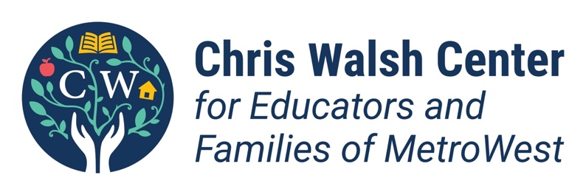
Fall 2022 Internship

What happens behind the scenes when educators and parents/guardians need support? The mission of the Chris Walsh Center is to provide resources and help for educators and families, with a focus on children with disabilities, children who are gifted/advanced learners, and others with unmet needs. Our undergraduate internship is an opportunity to get involved with organizing workshops for teachers, support groups for parents, online resources, and more. We are looking for interns with experience, dedication, and passion in education, child and family studies, psychology, sociology, marketing, or a related field.

Qualifications:
- Flexibility, creativity, curiosity, initiative, and a desire to support others.
- Ability to work 8-10 hours/week with the center, including some evening events
- GPA of 2.75 minimum
- To qualify for CHOICE funding ($16/hour), see additional requirements at: https://www.framingham.edu/the-fsu-difference/career-services/students/Internships/index

Examples of Intern Responsibilities:

- Help plan a lecture/webinar for educators to learn about a topic like best practices for culturally responsive special education with bilingual students.
- Evaluate web resources to add to the center’s website.
- Write a 1-page research brief summarizing a journal article, recommending action steps for educators, and posting it to the center’s website and social media.
- Support faculty members with research, data collection and analysis, and sharing results.
- Research and create content for social media.
- Write articles for the newsletters.

To Apply:

Email: chriswalshcenter@framingham.edu

To Learn More about the Chris Walsh Center:

Web: www.framingham.edu/chriswalshcenter

